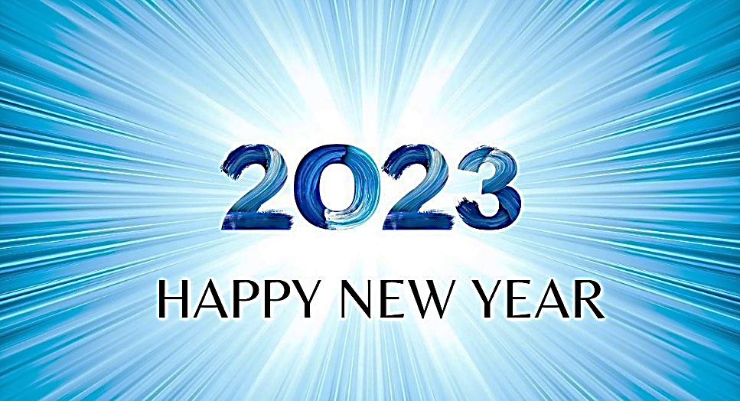
“And so we have the prophetic word confirmed, which you will do well to heed as a light that shines in a dark place, until the day dawns and the morning star rises in your heart.” (2 Peter 1:19)

We ended our last sermon in 2022 thinking of this grand passage from Peter’s last inspired letter. He died convinced that Jesus of Nazareth is the Christ, the Son of the living God. He knew, as only two other men on earth at the time, that Jesus was greater than Moses and Elijah (both of Old Testament fame). Legend has it that Peter died a horrid death because he would not give up that grand confession!
A new year has emerged; 2023 is here! Today is a right day to start afresh; to allow the Morning Star (Revelation 22:16) to rise to the pinnacle of your heart. It doesn’t matter now how difficult, terrible or troubling 2022 was. And it doesn’t matter how 2023 maybe looking in your headlights! What matters? Today; it’s the perfect day to say: the light of Jesus is going to shine in my heart! It’s the 1st day of 2023; rekindle your spiritual fire that Jesus seeks to ignite in your soul! Happy New Year!

