Do The Ends Justify The Means?
Joel Raulerson / Poudre Valley e-bulletin

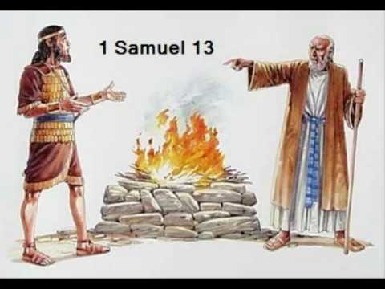
Do you pause to consider what the Lord would have you do? Have you ever considered how the Lord wants you to serve Him? Many claim they are acting in obedience to God, yet they do not pause to learn what He would have them do. They think that the “end justifies the means!” Some make excuses that what we are doing is in harmony with God’s will. However, serving God your way rather than as He commands is never the right answer.
King Saul was guilty of thinking that the ends justify the means. When Saul’s army was about to flee because of the might of the Philistine army that stood before them, he was willing to contradict God’s law to appease the people (1 Samuel 13:6-8). The context of 1 Samuel 13 reveals that Samuel was supposed to have come from Gilgal to offer a sacrifice for the people, but he was late. Saul, in an effort to quell a potential rebellion that he feared was coming, offered the sacrifice instead of waiting for Samuel or even conferring with the Lord (1 Samuel 13:9-12). Saul gives us a great example of trying to excuse his actions because the ends justify it. No matter how hard we try to justify what sounds good to us, if we act where God has not spoken we will pay the price as Saul did. Saul tried to justify his actions to Samuel by saying that if he had not offered the sacrifices, the people would have fled. Saul offered an excuse similar to what many attempt to offer today when they say, “the ends justify the means.”
The excuse that the ends justify the means has never been a scriptural concept. God’s word teaches us the exact opposite. In the case of Saul attempting to keep the army together, he sinned before the Lord and was told he would suffer the consequences. Samuel says in 1 Samuel 13:13-14, “You have done foolishly. You have not kept the command of the LORD your God, with which he commanded you. For then the LORD would have established your kingdom over Israel forever. But now your kingdom shall not continue. The LORD has sought out a man after his own heart, and the LORD has commanded him to be prince over his people, because you have not kept what the LORD commanded you.”
If Saul had simply waited on the Lord and consulted Him, all of this could have been avoided. He would have been blessed with victory and God would have blessed him and his family. Instead, the kingdom would now be taken away and he would lose his throne because He did not consult the Lord.
Many people today might say that Saul did not do anything wrong. They might suggest that Saul was doing his best to raise morale and keep the army together before the Philistines saw their cowardice and swept in to destroy them. However, we must remember that we do not see as God sees (1 Samuel 16:7). No matter what ideas we may have, God’s plans are always the best. Even if it looks like we have figured out a way to serve Him in a “better” manner, the ends never justify the means (Romans 3:8). Let us strive to do only as God commands and never go beyond those boundaries (Jeremiah 10:23).

