God With Us
Doy Moyer / LaVista Church Of Christ
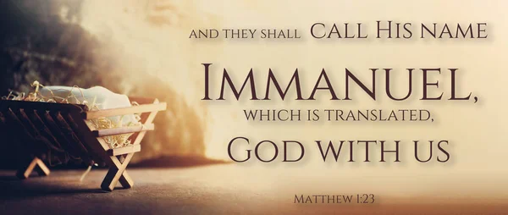

The coming of Jesus into this world, with all it entails, is more important than any or all events in this world combined. The light has come into a world of darkness, and darkness could not comprehend it. God is with us. Consider that Joseph was told not to be afraid to take Mary as his wife, “She will bear a son, and you shall call His name Jesus, for He will save His people from their sins” (Matthew 1:21). All this took place to fulfill what the Lord had spoken by the prophet, “Behold, the virgin shall conceive and bear a Son, and they shall call His name Immanuel” (Matthew 1:23).
The name “Jesus” tells us that God would save His people from sin. The name “Immanuel” tells us that God is with us. This encompasses the purpose of Jesus in coming as the manifestation of God in the flesh in order to save us from sin. This is the gospel of God’s grace. Jesus is the light shining in the darkness.
John concurs with the identity of Jesus. He is the Word, God the Creator, and “In Him was life, and the life was the light of men” (John 1:4). John then says, “And the Word became flesh and dwelt among us, and we have seen His glory, glory as of the only Son from the Father, full of grace and truth” (John 1:14). The glory of God is seen in Jesus even as He came in the flesh to show humanity life and light. He would do this by going to the cross, for, as He said, “‘And I, when I am lifted up from the earth, will draw all people to Myself.’ He said this to show by what kind of death He was going to die” (John 12:32-33). The glory of God is seen because there, in the cross, the love of God is on full display.
Let’s come back to the name “Immanuel,” God with us. This is applied to Jesus in the ultimate fulfillment of the promise made in Isaiah 7:14. When a sign is promised by the Lord and fulfilled, it is evidence that God is with us. When Jesus was born, the virgin bearing a child was a sign from God of His presence. But this wasn’t just His presence in a general sense that He is there watching over. His presence was in the very person of the Son, Jesus Christ. He is Immanuel incarnate.
The name Immanuel is found again in Isaiah 8. Ahaz failed to listen to Isaiah. The people were floundering in their faith, guilty of idolatry and evil, and the warnings of judgment were clear. Assyria would come down as a flood upon Israel and sweep into Judah, “it will overflow and pass on, reaching even to the neck, and its outspread wings will fill the breadth of your land, O Immanuel” (Isaiah 8:8). The people were then told to be broken and shattered. Their counsel would come to nothing and their word would not stand, for “God is with us” (Isaiah 8:10). Judgment was upon them.
Perhaps it seems strange to think that Immanuel here encompasses judgment. Yet in Jesus, who is Immanuel, we find both the sign of God’s presence that brings salvation (“Jesus”) and also the judgment that comes in rejecting Him. Recall that Jesus is the Stone of Stumbling and Rock of Offense. He is the rejected Stone, and “the one who falls on this stone will be broken to pieces; and when it falls on anyone, it will crush him” (Matthew 21:44). As the people were broken and shattered because of God’s presence, so it is with Jesus. For those who reject Him, the message is the same: be broken and shattered, for God is with us. We cannot escape His judgment or His presence.
The fact that Jesus is Immanuel drives home the significance of His sacrifice. Jesus is not a lamb equal to the animals given every year, for “it is impossible for the blood of bulls and goats to take away sins” (Hebrews 10:4). No, this is Immanuel for whom a body was prepared with the expressed purpose of dying in humiliation on a cross. He despised the shame of it (Hebrews 12:2), but it was through the cross that He would display love and grace, and draw the world to Himself as the beacon of light and life. This is God, humbling and emptying Himself, treating others as more important even than Himself (Philippians 2:3-8). Only He could provide this gift, and He did it lovingly and willingly for us. In the cross, God is with us, and this is amazing, beyond words to express how marvelous this is!
When we see Jesus, we are left with two options: accept Him as Lord and God or deny Him as a fraud. We receive Him as the Cornerstone on which our faith is built or we stumble over Him as the Rock of Offense. Yet whether through salvation or judgment, we find this truth: God is with us.

