How Men Act When They Repent
Steve Klein / Auburn Beacon

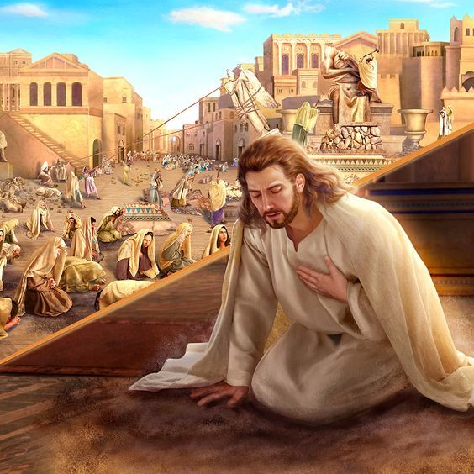

In Matthew 12:41, Jesus said, "The men of Nineveh will rise up in the judgment with this generation and condemn it, because they repented at the preaching of Jonah; and indeed a greater than Jonah is here." According to Jesus, the men of Nineveh repented at the preaching of Jonah.
You remember the story, don't you? God had commanded Jonah, "Arise, go to Nineveh, that great city, and cry out against it; for their wickedness has come up before Me" (Jonah 1:2). Now Nineveh was not only a city filled with wickedness, it was also the capital of the Assyrians, hated enemies of the Israelites. Jonah didn't want to go. He fled from God's presence.
However, after being given some quality time in the belly of a fish to reflect and pray, Jonah decided to obey God. Jonah walked through the city proclaiming the judgment of the Lord upon these pagan people, "Yet forty days, and Nineveh shall be overthrown!" (Jonah 3:4).
The people of Nineveh repented. They "proclaimed a fast, and put on sackcloth, from the greatest to the least of them" (Jonah 3:5). When word came to the king of Nineveh, "he arose from his throne and laid aside his robe, covered himself with sackcloth and sat in ashes." He decreed that "neither man nor beast, herd nor flock" were to eat or drink and that everyone was to "turn from his evil way and from the violence that is in his hand" (Jonah 3:7-8).
The text says that, "God saw their works, that they turned from their evil way; and God relented from the disaster that He had said He would bring upon them" (Jonah 3:10). God can read men's hearts. He knows more about what is going on in our heads than we do ourselves. But He did not need to read the minds of the Ninevites to know that they had repented. He "saw their works, that they turned away from evil". When the men of Nineveh repented, nobody was left to wonder whether or not their repentance was genuine. Nobody was left guessing about their intention to stop committing evil. Nobody would have doubted they had actually repented of their sins.
We really need to learn this lesson from the men of Nineveh. We need to learn how to act when we repent. Repentance isn't just saying "excuse me," "my bad," or "forgive me," and then going on with our lives as if nothing happened. Repentance should produce real change in our actions. We are to "bear fruits worthy of repentance" (Matthew 3:8). I am afraid that too many of us think that our repentance should go unnoticed. We are incognito repenters! And while God hardly asks us to don sackcloth and ashes today, He does ask us to, "do works befitting repentance" (Acts 26:20).
Let's resolve to turn away from sin in our lives, and make sure that we behave in such a way that folks can tell that's what we've done!

