Pew Casualties
Wilson Adams / FB blog

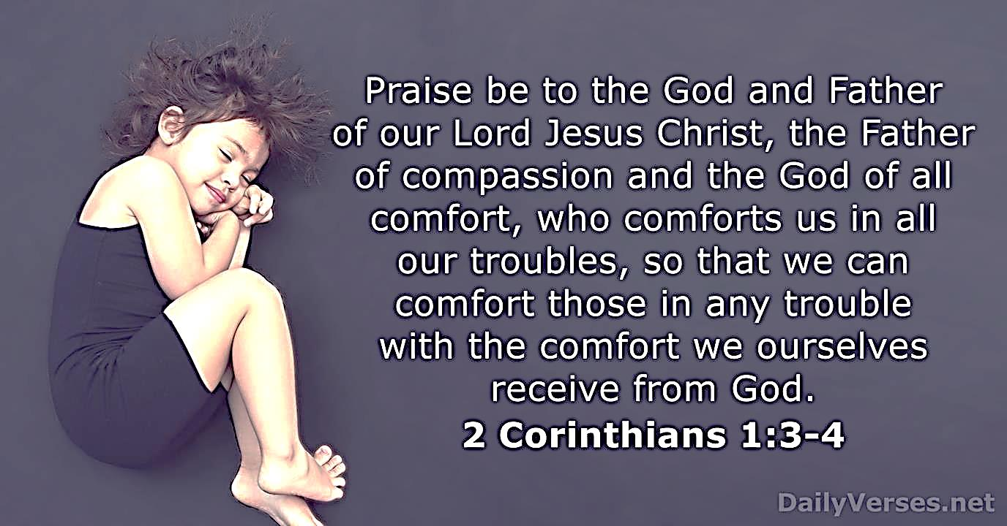

Rarely is there a family sitting in a pew without sadness or skeletons. Life gets messy – very messy. Many walk in the church door limping whether you can see the wound or not. These casualties come in all shapes and sizes, both genders, and all ages. They sit with superficial smiles, big emotions, hidden hurts and agonizing addictions – all looking for help and hope.

Sometimes they are ignored; sometimes they are abhorred.

How to find the biblical balance? Truth and grace... law and love... proclamation and consolation... It’s a hard balance.

Marriages teeter on the brink of divorce. Peer pressure promotes gender confusion. Ours is a generation that believes it's more important to recycle than abstain from porn. Sadly, we assume people are godly only because they sit in a pew. Sam Serio (Sensitive Preaching) - “Church is one of the best places to hide your sin.”

Regardless of the times, the POWER of the Spirit’s Word has not changed. God is the solution for any kind of hurt or habit. He is the God of hope and the God of all comfort. There is no emotional pain or sin in the world that lies beyond His amazing grace. None.

Instead of the last place to go for healing, He is the first place. BTW, He has some incredible Jesus-servants He uses to help us heal. I hope you find them. They get it. If you know one, you are blessed.

