Kansas City Chiefs VS San Francisco 49ers
Kenneth D. Sils

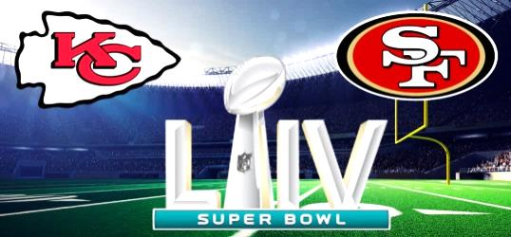

OK… who won? I don’t know? This little blurb was written two days before the big game and you may be reading this before kick-off late this afternoon; oh, the anticipation!
Now, don’t get over excited about the point I’m making for I too am a sports fan. I have favorite teams and can get rather “excitable” about my team making it to a championship, especially for “March Madness”. My point: does this football game really matter? In the long, long view of everything, the answer is: NO! I know, there are all types of consequences that can come from such major sporting events that can affect a lot of folks, but the truth of the matter: it really doesn’t matter!
Why do I say that? Because Peter said, “But the day of the Lord will come as a thief in the night, in which the heavens will pass away with a great noise, and the elements will melt with fervent heat; both the earth and the works that are in it will be burned up” (2 Peter 3:10). Someone may say, “Well, since you’ve put in those terms; Super Bowl 54 really doesn’t matter after all!”
Remember: do all things in perspective. Make sure you don’t get too carried away with the “cares, riches and pleasures” of life which, as Jesus taught in the Parable Of The Sower, can cause Christians to fail bringing spiritual fruit to maturity. Peter told us in 2 Peter 3:11, “Therefore, since all these things will be dissolved, what manner of persons ought you to be in holy conduct and godliness.” Enjoy the game, but remember – our Lord, Jesus Christ is coming one day and then, the souls of men will be weighed in the balance of keeping His commands. Now, that will be the real Super Bowl!

