The Lord Is My Shepherd
Kenneth D. Sils

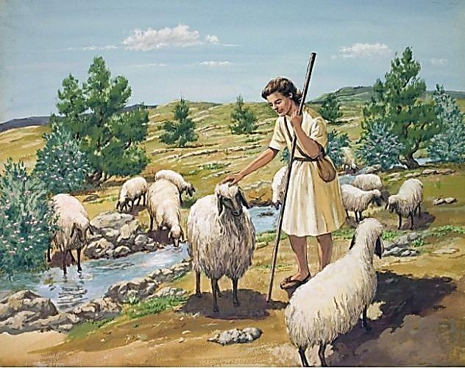
“The Lord is my shepherd; I shall not want.” (Psalm 23:1). Those are some of the most famous words ever penned! This grand proclamation came from David, the sweet singer and 2nd King of Israel. Many of the Psalms we have reserved for us in the Old Testament come from David’s pen and a good section of Old Testament Scripture is devoted to his story.
Why is so much attention focused on David? It is this man that God historically painted with the moniker: a man after God’s own heart, (Acts 13:22). We know from David’s story that he was anything but perfect, yet we learn that he made it his life’s mission to serve God. When he failed in his service, he accepted those failures, confessed his sins and did his best (both publicly & privately) to make amends and find restoration towards God’s good graces.
Doesn’t that sound like Christians? As Christians, we know who our “Good Shepherd” is and live as Jesus said, “My sheep hear My voice, and I knew them and they follow Me.” (John 10:27). We believe in Jesus, causing us to give our best in aligning our hearts with God’s heart! We recognize Jesus is our Lord, Savior and Shepherd, moving us to change our life in obedience to His Divine New Testament precepts. We are members of His church, citizens in His heavenly kingdom and have taken our place among Christ’s sacred body of believers.
Our Good Shepherd has instructed us to take His light and let it shine before a lost & corrupt world. This is one of the reasons we try to have Gospel Meetings on a regular basis. We want to reach out to our friends and neighbors in our community with the message of God and Gospel Meetings give us special opportunities to do that. It allows us to re-energize our desire and passion for God as we come together several times in a week to worship and praise God as a local body of Christ. Lord willing, beginning this Thursday evening, we’ll meet to worship God and hear Brigham Eubanks preach Bible sermons focused on King David’s life lessons which prompted him to be marked as: a man after God’s own heart. Let’s all plan to be here!

