The Lord Will Trouble You This Day
Kenneth D. Sils

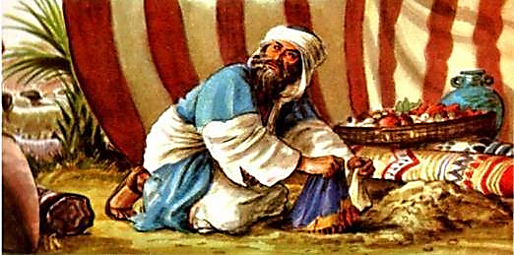

What a terrifying statement that title is! But, it was fitting on that great day of judgment, centuries ago among ancient Israel; the execution of Achan from Joshua 7. And what did Achan do that warranted such trouble? Joshua said in Joshua 7:1 that Achan took of the accursed things! An amazing victory takes place and Jericho lies in ruins. Achan was a warrior of Jehovah. He must have spotted some of the enemies spoil (silver and gold), grabbed some for himself, took it to his tent and buried it for a later day. Actually, that doesn’t sound all that horrible, does it? Israel isn’t going to miss just a little silver and gold from all that would found throughout Jericho’s ruins. And, what did they really need with that anyway?
God said not to take any of it! Joshua 6:18, “And you, by all means abstain from the accursed things, lest you become accursed when you take of the accursed things, and make the camp of Israel a curse, and trouble it.” Joshua couldn’t have been clearer to the army before “those walls came a tumblin’ down”, but Achan took of the accursed things!
This infamous chapter is SCREAMING at us: when we disobey God (and we do that when we disobey His ordained spokesmen), we are asking for: trouble. Sin bears a hard truth: trouble is sure to come our way and there is no way to hide or run from it. God will bring His judgment down upon the disobedient, like Achan. A day of trouble is coming for, “those who do not know God and on those who do not obey the gospel of Jesus Christ. These shall be punished with everlasting destruction…, 2 Thessalonians 1:9-10.” So many about us are just like Achan, disobeying God and will face: trouble. Be sure you’re not among them!

