Why No “Fellowship Hall” Or Gym?
Ron Halbrook – Guardian Of Truth Magazine

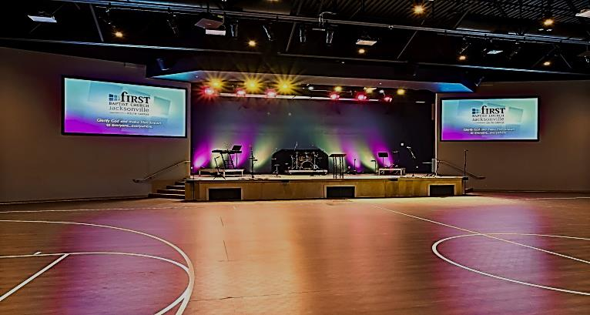

One of the questions increasingly asked by those who visit our service, “Why do you not have a ‘fellowship hall’ or gym where the church can sponsor social meals, parties or recreational programs?” That is a good question – one that is worthy of a Biblical answer. It can be answered in just a few words, “We do not have such facilities because God has not authorized the church to sponsor social meals, parties or recreational programs.” All that one does is to be done “in the name” (or by the authority) of the Lord, Colossians 3:17. Since He has not told the church to sponsor such activities, we do not have the right to assume it is alright to serve Him by means of the “fellowship hall” or gym.

It Is NOT Because:
1. We do not like food and fun. Members of churches of Christ like food and fun as well as anyone else. Often social meals, parties and recreational activities are enjoyed at home or in situations other than the work of the church.
2. We cannot afford them. When we are getting new congregations started by preaching the gospel, often people suggest that we do not have social activities and recreational functions because we are few in number and the church is just getting started. NO, we could have afforded them then and could afford them now – that is not the reason.
3. We do not have anyone to conduct them. Some of the best cooks in the world worship with the church of Christ. Many members play ping pong, soft ball and other games. Some even make their living as teachers of home economics and as athletic coaches. But, they do not play these roles when they gather to worship God and conduct the work of the church. (on back)

