Gospel Meeting: March 15th - 18th

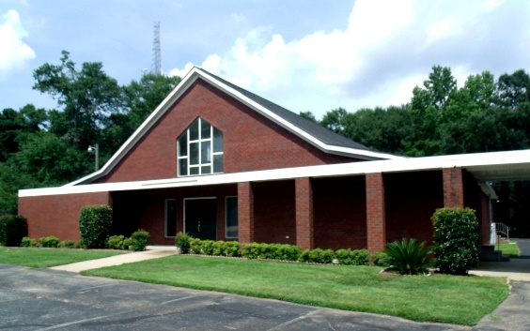
Our 2026 spring Gospel Meeting plans have changed. Tommy Holly is not able to preach our meeting due to his recent health troubles, but we are going to have a great Gospel Meeting anyway!

Our Theme: So Roll Up Your Sleeves, Put Your Mind In Gear from 1 Peter 1:13 (The Message… a Bible paraphrase). We will present 5 Bible messages:
Sunday 1st Sermon - Ken Sils = 1 Peter 1
Sunday Main Sermon - Ken Sils = 1 Peter 2
Monday Night Sermon - Brad Sullivan = 1 Peter 3
Tuesday Night Sermon - Ben May = 1 Peter 4
Wednesday Night Sermon - Casey Gray = 1 Peter 5

