Anchors In Troubled Times
Keith Greer / Auburn Beacon

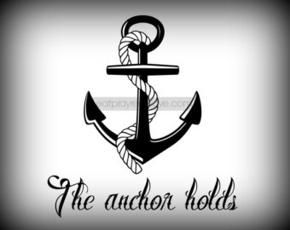

Often times this world can be a cruel place. Who has lived life on this earth without facing difficulties or heartaches? Mankind will always have to deal with the three T's: testings, tribulations and trials. The Scriptures abundantly teach this to be so (1 Peter 1:6-7; 4:12-16; 5:9; 2 Timothy 3:12).
Each of us has our own burdens to bear. Some Christians seem to believe that God has placed them under a "protective umbrella," where no unpleasantness can enter. Comforting, but not accurate! Life on earth is a package deal. We must take the good and the bad (Matthew 5:45).
What do we do when these times come upon us? Where do we turn in times of trouble? Many folks make the problems worse by turning to the wrong source for help. Did God leave us without hope or recourse? Can we face life's problems and overcome them?
We can if we have some "anchors." What is an anchor? It is a source of security or stability (American Heritage Dictionary). God has provided some "anchors" to aid us in our journey down the uneven pathways of life. Do they work? Together we will endeavor to answer these questions.
1) The Word of God. God's word is inspired. Who created man? Who better understands man? Who can be a better counselor? "All Scripture is given by inspiration of God, and is profitable for doctrine, for reproof, for correction, for instruction in righteousness, that the man of God may be complete, thoroughly equipped for every good work" (2 Timothy 3:16-17). "Profitable" means for our good. God's word can equip us for every good work. Do we turn to His word in times of trouble?
2) Prayer. The Bible tells us to "pray without ceasing." "Be anxious for nothing, but in everything by prayer and supplication with thanksgiving let your requests be made known to God” (Philippians 4:6). Do we tell God our troubles? Do we always think to pray? We have a special relationship with God, a Father and son kind of relationship. It is so sad that people in the world do not have this blessing. We have it and don't use it! If we don't turn to Him we show a lack of trust and faith in Him. Never underestimate the security of this anchor.
3) The church. Why are we called the "family of God"? Who better understands the struggles of my life as a Christian than another Christian? Read these passages: John 13:34-35; 1 John 2:9-11; 3:15-18; 4:19-21. God commands us to love our brethren. When facing the onslaught that life can give you, whom do you turn to first? People of the world or your brethren? Who is going to heaven? If we don't care now, we won't get the chance to care later!
4) The hope of eternal life. Why did Abraham leave his homeland? To offer Isaac on that altar? "...for he waited for the city which has foundations whose builder and maker is God” (Hebrews 11:10). He had his focus on something better! We need to keep “focused” on heaven. Read Philippians 3:12-16; 2 Peter 1:3-4. We are told by Paul to "lay hold on eternal life" (1 Timothy 6:12). This is our most prized possession. Do not allow it to slip through your hands. Troubles are temporal!

