ANTITHEISTS
Mark W. White / Westview Bulletin

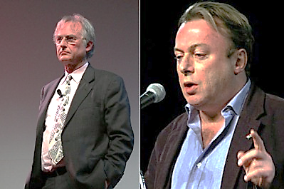

Is this word foreign to your vocabulary? Perhaps it is the time for the faithful to define it and use it as we try to understand what is happening in the world around us.
The Oxford English Dictionary defines ANTITHEISTS as “one opposed to belief in the existence of God.” The term allows a useful distinction between simply not believing in God and actively attacking belief in God.
If someone takes the view that belief in God is destructive, he is an ANTITHEIST. These maintain that all religions are untrue and harmful to others. A number of years ago, evolutionary biologist Richard Dawkins and others formed a group of intellectuals who mounted a pro-atheism, anti-religious campaign. Dan Barker, an American atheist writer, coined the phrase “evangelical atheism” to describe this new militancy of unbelief. Dawkin’s book, The God Delusion has been popular, as well as another volume by Christopher Hitchens titled, God Is Not Great: How Religion Poisons Everything. As a result, ANTITHEISTS are receiving quite a hearing among people nowadays. If their influence grows, Christians should be gravely concerned.
In some professions, especially academia, Christians are feeling increased pressure to hide their faith. As ANTITHEISTS ramp up their rhetoric and increase their hostility, we will see their influence take greater hold in other areas of society. Richard Dawkins seriously puts forth the idea that religious training of children is a form of child abuse! This is quite a disturbing thought to Christians, for sure. As we should have learned already with social issues ranging from the acceptance of homosexuality as a valid lifestyle to abortion on demand, what was once unthinkable yesterday will likely be commonplace tomorrow.
Christians must prepare themselves for the possibility of persecution. If we are having trouble being faithful today, just what will happen if tomorrow brings ANTITHEISM as a prevailing cultural norm?

