Because He Believed In God
Tracy Dugger / Fulton County Gospel News
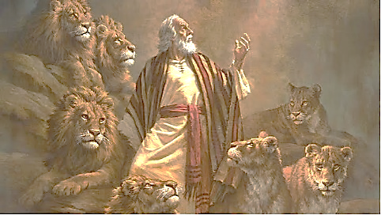

These words were spoken of Daniel after being delivered from the hungry den of lions. Our God is able to carry us through life’s trials when we trust in Him with all our being. Daniel did this – he trusted in God and was delivered.
We live in a world where the righteous are often persecuted. Daniel is a prime example. Let us consider how inspiration describes his character and dedication. In Daniel 6:4, “Then the presidents and princes sought to find occasion against Daniel concerning the kingdom; but they could find none occasion or fault; forasmuch as he was faithful, neither was there any error or fault found in him.” The jealousy of the Babylonian officials raged against Daniel. These prominent officials undoubtedly took a fine-toothed comb to the character of Daniel but could find nothing in which to charge him. Why? “Forasmuch as he was faithful, neither was there any error of fault found in Him” (Daniel 6:4). He was faithful in carrying out his duty not only in the religious realm but in the secular realm. In Daniel 6:22, we read, “also before thee, O King, have I done no hurt.” Daniel was righteous, honest, true and of excellent spirit. Friends, this was a good man. Yet, there were those who despised him and wanted his destruction! This has always been the case for our world. The innocent and righteous always are persecuted for their righteousness. Daniel is proof of such!
In response, did Daniel blame God, becoming pessimistic or becoming unfaithful? No! Why not? Because he believed in God! Daniel did not give up! He remained true to God throughout his entire life – a life that included much trial and anxiety.
In Daniel 10:12, we find a little more that sheds light on Daniel’s ability to endure trials. Inspiration says that he chastened (disciplined) himself before God. This tells us that he was a deeply religious man. His mind was so focused on God that religious matters took precedence in his life (Matthew 6:33). Earlier in this verse, it was said that he set his heart to know and do. We too must realize that the Christian life is to be a deliberate and calculated one, not just an occasional interest. The church needs more people who will overcome when faced with crisis, temptation, persecution and discouragement. In short, we need more Daniel’s!

