Being Real
Richie Thetford – Poudre Valley e-bulletin

An antique dealer thought that the wrinkled old baseball card that she found might be worth $10.00. After posting it on eBay, she began to wonder if it might be more valuable than she had thought. She removed the posting and consulted a professional evaluator who confirmed that the photo on the 1869 card showed the Cincinnati Red Stockings, the first professional baseball team in the U.S. The card sold for more than $75,000.00. Even though the card was creased and discolored, the most important thing was its authenticity – it was real!

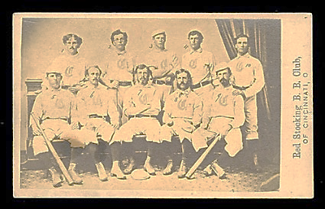

Paul and his companions suffered greatly while spreading the gospel of Christ. In 2 Corinthians 6, he listed their outward trials, their inward traits and their spiritual resources. “But in all things we commend ourselves as ministers of God: in much patience, in tribulations, in needs, in distresses, in stripes, in imprisonments, in tumults, in labors, in sleeplessness, in fastings; by purity, by knowledge, by longsuffering, by kindness, by the Holy Spirit, by sincere love, by the word of truth, by the power of God, by the armor of righteousness on the right hand and on the left” (2 Corinthians 6:4-7). Try to imagine if you will the circumstances in which all these things interacted: beatings, patience, prison, kindness, distress and love. Although broken physically, depleted emotionally and tested spiritually, the authenticity of their faith in Christ clearly showed through! “As sorrowful, yet always rejoicing; as poor, yet making many rich; as having nothing, and yet possessing all things” (2 Corinthians 6:10).
The point is this – in our walk with Christ, there is absolutely no substitute for spiritual authenticity – being real! It is not enough for us to simply say, “I am a Christian.” We must prove it to ourselves, others, and most importantly to our loving Father by our actions throughout the day. Our spirituality and progress should certainly be evident to all and it will be when we take it seriously. When we do, then it will be real!

O to be like Thee!
O to be like Thee!
Blessed Redeemer, pure as Thou art;
Come in Thy sweetness, come in Thy fullness;
Stamp Thine own image deep on my heart.

