Mount Rushmore National Monument
Ken Sils

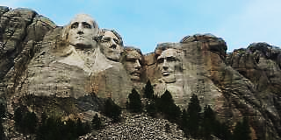
That’s not a bad picture from an amateur photographer, right? I know, I could use a few tips, but I’m one of those who just grabs my cell phone and… snap! Sandra and I really enjoyed our trip to South Dakota as we celebrated our 40th anniversary of marriage together. We give God all the glory for His watchful eye and a safe return!
Let me encourage you to take a trip across the fruited plain. Although we are still road-weary, the scenery was, let me say it this way – NOT Mobile! We were amazed at some of the topography we saw in Nebraska, and especially in South Dakota, Wyoming and Montana. Big Sky country, indeed! How true are the words of the Psalmist in Psalm 95:4-5, “In His hand are the deep places of the earth; the heights of the hills are His also. The sea is His, for He made it; and His hands formed the dry land.” I can’t tell you how many times either me or Sandra commented, seeing some amazing display of God’s creation, “How can people say there is no God?” Sadly, Paul was spot on for that question in Romans 1:20-22, “For since the creation of the world, His invisible attributes are clearly seen, being understood by the things that are made, even His eternal power and Godhead, so that they are without excuse, because, although they knew God, they did not glorify Him as God, nor were thankful, but became futile in their thoughts, and their foolish hearts were darkened. Professing to be wise, they became fools.” We often fail to embrace what is right before us. Our eyes often have blinders on them. Being just a few miles from the Gulf Of America, we don’t have to drive far to be impressed with God’s creation. Stop! Look at what is around you and remember: the God of the Bible made it all! (continued on back)

