I Love Those: Sentence Sermons

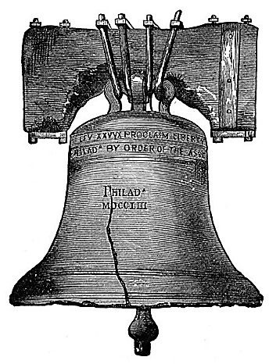

To know the Bible is to obey it.
Jesus is the Way – the only Way.
Decay begins when growth stops.
Let’s hate the sin, but love the sinner.
At the cross, God’s justice and mercy met.
Love never asks, “How much will it cost me?”
By what we are practicing proves what we are professing.
When Christ rules our hearts, peace can finally rule in our soul.
Looking towards heaven surely makes this world a lot less desirable.
Instead of praying for an easier life, let us pray to be stronger men and women.
If you do not live what you believe, your belief should be increased so that you will.
The devil accomplishes much evil through some who claim to love the Lord - Beware!
An admission (and correction) of error is not a sign of weakness, but a sign of strength.

