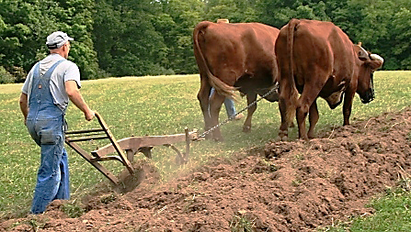
“Sow for yourselves righteousness; reap in mercy …
[but] you have plowed wickedness; you have reaped iniquity.” Hosea 10:12

You and I may have never lived or worked on a farm, but consider for a moment that, spiritually speaking, you and I are farmers indeed! Given the prevalence of agrarian cultures in biblical times, the Holy Spirit chose to frequently use farming terminology and idioms to get across various messages. Such was the case when Hosea wrote some 2,700 years ago.
First of all, notice that you and I are each individually responsible for our own actions in sowing, planting and being fruitfully productive. You cannot do the work for another person nor can anyone do for you what you’re responsible for. We must each act.
Additionally, if we sow righteousness, we will most certainly benefit from the very mercy which we certainly don’t deserve but that we desperately need. We are to live lives of righteousness so that good things will happen. And, while the good things (mercy included) may not come to us fully in this life, the mercy from our Lord in eternity will make all our sacrifices worth the effort!
Finally, we have to come to the full and clear realization that our choices to do wrong (plow with wickedness) will only result in bad things for us, both in this life and most certainly in the life to come. So often, you and I witness those in the world who ignore all that the Lord commands and they pay for it with their marriages, their health and their freedom. How sad it is to see people with great potential choose to squander their God-given talents and opportunities and then reap the results of their poor and sinful choices.
We must make sure to be responsible farmers with our words, deeds and even our thoughts. Let’s sow and plow with godly intent and enjoy the blessings of faithfulness that come from our good, glorious and eternal Lord. Leland Ping – FB post

