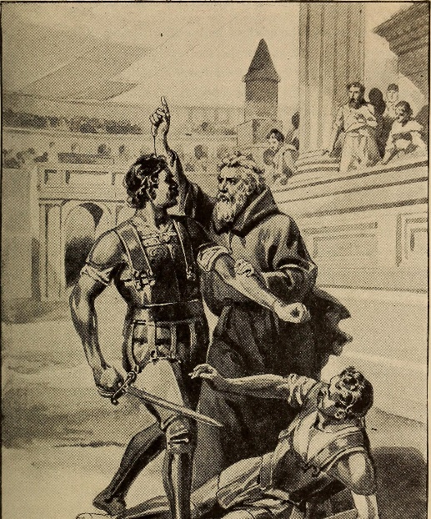In the year 404 A.D., a monk by the name of Telemachus traveled to Rome and was shocked beyond measure at the cruelty of the gladiatorial contests. Telemachus leaped over the railing of the Coliseum and tried to stop the gladiators from hacking themselves to pieces by repeated cries of, “in the name of Christ, stop!” The little monk stood his ground and refused to move. Shortly, he was slain by the gladiators who continued to fight standing over his dead body. But the little monk’s sacrifice was not in vain as the consciences of the Roman populace were stirred and Emperor Honorius soon decreed the bloody combat games be forever abolished.
The spirit of courage, exemplified by Telemachus, needs to be alive today as modern Christians struggle against deeply entrenched evils such as injustice, indifference and immorality.
The Lord’s church is a fellowship of courageous souls who have banded together with wickedness and all unrighteousness. The church of Christ was not established by cowards, nor has it been preserved by cowards. Let God’s people be lion-hearted and bold, neither fearing the frowns nor courting the favors of the world. Severe trials and tribulations will only serve to increase our fortitude. God “hath not give us the spirit of fear; but of power and of love, and of a sound mind.” (2 Timothy 1:7). Only by being courageous can we swim against the world’s current and move in the direction of God.
Bill Fulton/Fulton County Gospel News

