Two Rich Churches
Mike Noble - Central Shelby Searcher

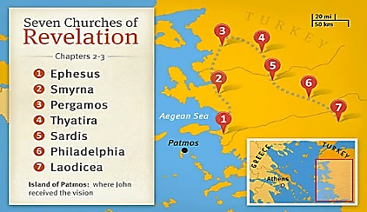

Things were not going well for the church in Smyrna –– from a worldly perspective, that is. In the letter addressed to them in Revelation 2, mention is made of their tribulation and how they had suffered at the hands of some Jews. Things weren’t to get any better soon, either. Some of them were about to be thrown into prison because of their faith –– perhaps, even executed. They were an impoverished people, financially speaking. (It doesn’t appear that they had heard of the ‘health and wealth gospel’ we hear preached so often today, does it?); yet the Lord looked at His people in Smyrna and said, “But you are rich” (Revelation 2:8). Hmmm....
About 100 miles away, the church at Laodicea was doing great –– or so they thought. They were rich and had everything they needed –– so they said. Yet the Lord looked at them and told them they were, “wretched, miserable, poor...” (Revelation 3:14).
“How can this be?” someone asks. Obviously, the Lord doesn’t look at riches the way we do. We can have all this world’s goods we desire, live in luxury -- even meet with 'saints' in a beautiful building -- yet if we are “lukewarm” in the Lord’s service (as was Laodicea), we are spiritually poor and without Jesus’ approval. On the other hand, we can be “rich,” even while living in squalor or rotting in a dungeon. If we have the Lord’s approval and, consequently, look forward to a “crown of life,” we are rich indeed!
In our materialistic culture, we need to continually reevaluate our thinking about riches. Material wealth is fine, though it comes with many weighty responsibilities (1 Timothy 6:17-19). What truly matters is whether or not we are spiritually rich.

